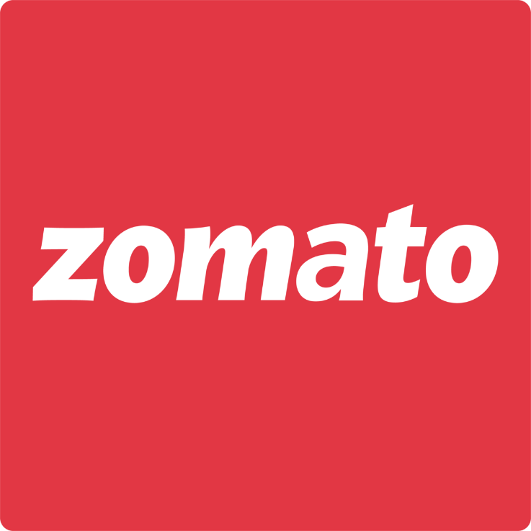

Report on: Zomato Case Study

Submitted By Mohammad Nehal, IIM Ranchi

**Management Consulting Leadership Programme by Skilled Sapiens**

**Overview**

Zomato is an Indian multinational restaurant aggregator and food delivery company. It was founded by Deepinder Goyal and Pankaj Chaddah in 2008. Zomato provides information, menus and user-reviews of restaurants as well as food delivery options from partner restaurants in more than 1,000 Indian cities and towns, as of 2022–23. Zomato was founded in the year 2008 as FoodieBay.

The countries where Zomato operated were:

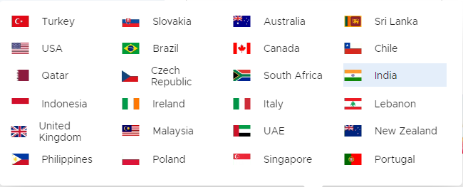

However, currently, Zomato is running its operations only in India and UAE.

**Current Scenario:**

The company has strengthened its presence in Tier 2/3/4 markets over the past year with its expansion, but at the same time it is embroiled in a long-standing battle with restaurants to change

its discount-happy ways. Whether this has a deep impact on Zomato’s overall business is yet to

be seen, but the fact is Zomato has opened up many more channels for revenue through its

business model diversification.

1. Restaurant Listings / Advertising

2. Food Delivery

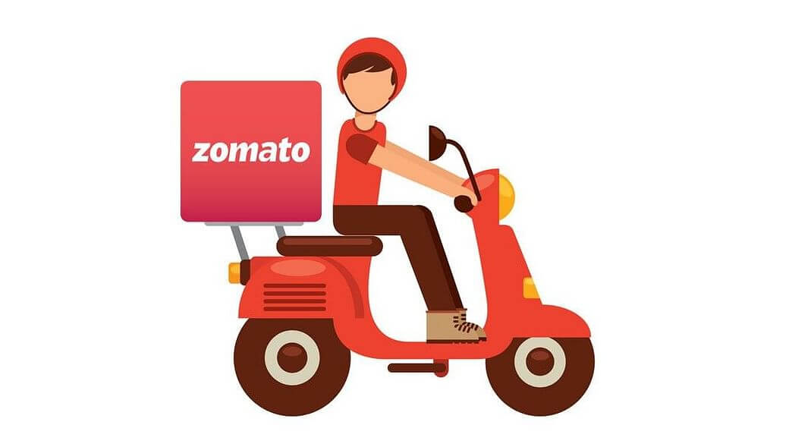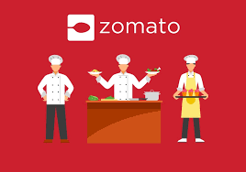3. Subscription Programmes

4. Live Events

5. White Label Access

6. Zomato Kitchens

**Problem Statement: Business Growth & Expansion.**

Now the company is looking for new business growth opportunities. After the launch of its IPO,

Zomato has observed many hiccups in its revenue streams and overall business growth.

Considering the upcoming recession forecast, the company wants to have a sustainable business

model that has the minimum impact of recession in the Indian market.

The space is already red-ocean, but the company feels that the introduction of new

products/services may change the game, and there is an opportunity to tap the market even more.

The company is keen to enter the market with diverse offerings to attract more

varieties of customers on its platform.

**Questions**

1. What is the current revenue model of Zomato & how is it different from the rest of the

competitors in the market? Do the BCG Analysis of the products/services of Zomato &

highlight key areas for Growth and expansion scope

2. With the dominance of many players in the segment, find out ways it can position

itself, and create differentiation from the other competitors in terms of positioning and

product offerings

**Consider Hyperpure as your reference,**

3. As a Growth & Strategy consultant, you need to come up with a set of implementable

approaches to assist Zomato business leaders in getting a Competitive advantage,

Market Penetration, New revenue streams, cost analysis, cost cutting, and more clients

on-boarding strategies

4. How the introduction of Hyperpure can be a game-changer for Zomato, suggest key focus

areas for Zomato & and various strategies to form a sustainable business model. Justify your

findings by creating different user personas & use cases basis on your business

understanding of HyperPure

**Zomato’s Current Revenue Model**

**FOOD DELIVERY ONLINE FOOD ZOMATO**

**ORDERING ADVERTISING**

Restaurants and food-related businesses can pay Zomato to promote their listings on the platform, increasing their visibility to potential customers.

Zomato offers a subscription service called Zomato Gold, which allows users to get special discounts and offers at partner restaurants. They generate revenue from this subscription fees for this service.

Zomato charges a commission fee from restaurants based on the number of orders placed through their platform. This fee can vary based on the restaurant’s location, size, and partnership agreement with Zomato

**CLOUD KITCHENS GROCERY DELIVERY HYPERPURE**

Zomato expanded its services to include grocery delivery, allowing users to order groceries through the app. Revenue is generated through delivery fees and partnerships with grocery stores.

Zomato operates a business-to-business (B2B) arm called HyperPure, which supplies high-quality ingredients and raw materials to restaurants. This generates revenue from sales to restaurant partners.

Zomato ventured into cloud kitchen operations by setting up its own kitchens and renting them out to restaurant partners. They generate revenue from rental fees and a share of the sales made by the restaurant brands operating in these kitchens.

BCG MATRIX

Growth Rate

High

Market share

|  |  |
| --- | --- |
| **QUESTION MARKS**   * Zomato's cloud kitchen and grocery delivery services could be categorized as "Question Marks." These segments have potential for high growth but may not have attained a dominant market share yet. * Zomato is still expanding these services and investing in them, aiming to capture more market share. | **STARS**   * Zomato's core food delivery and restaurant discovery services * These services are experiencing rapid market growth, driven by increasing demand for food delivery and dining out options, especially in urban areas. |
| **DOGS**  Low   * Zomato's B2B arm, HyperPure, might be considered a "Dog" in the BCG Matrix. While it provides a valuable service to restaurants, it may not have a significant market share compared to some of Zomato's other offerings. * The market growth for restaurant supply chain services may not be as high as other segments.   Low | **CASH COWS**   * Zomato Gold subscription service can be classified as a "Cash Cow." It has a relatively high market share in the subscription segment for dining discounts and offers. * Market growth for such subscription services may not be as high as food delivery, but they generate consistent revenue with a strong customer base.   High |

Competitor Analysis

|  |  |  |  |
| --- | --- | --- | --- |
| **Feature** | **Zomato** | **Swiggy** | **Uber Eats** |
| **Range of services** | Food delivery, restaurant discovery, table booking, online grocery delivery | Food delivery, restaurant discovery, table booking | Food delivery |
| **User experience** | More comprehensive | Less comprehensive | Less comprehensive |
| **Brand recognition** | Stronger | Weaker | Weaker |
| **Financial stability** | More stable | Less stable | Less stable |
| **IPO** | Has gone public | Has not gone public | Has not gone public |

**PORTER’S FIVE FORCES MODEL ANALYSIS ON ZOMATO**

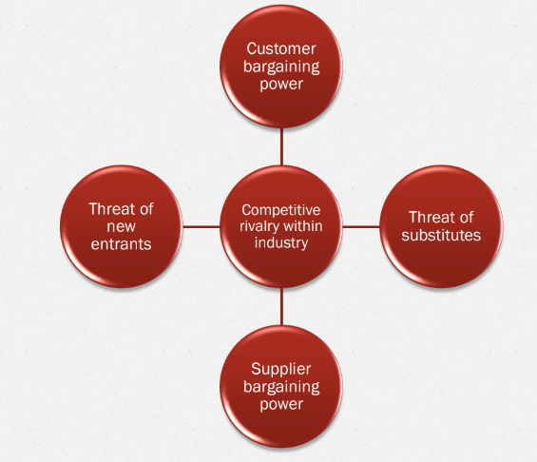

LOW BECAUSE OF DUOPOLY B/W SWIGGY AND ZOMATO

MEDIUM TO HIGH RANGE

HIGH THREAT

LOTS OF SIMILAR APPS

EASE OF SHIFTING

GROWING MARKET

HIGH INTENSITY

HIGH BUYING POWER OF CUSTOMER

**THREAT OF NEW ENTRANTS:** The threat of new entrants is low as the market is almost duopoly with Zomato and Swiggy capturing almost 95% of the market share in the food delivery market in India.

**THREAT OF SUBSTITUTES:** The threat of new substitutes is high because of lots of apps and the ease of shifts as the customers can compare services and prices and shift easily.

**BARGAINING POWER OF SUPPLIER:** They are high as Zomato is dependent upon them for deliveries but since there are also many suppliers we rate it medium to high.

**BARGAINING POWER OF CUSTOMER:** The market price being sensitive, the bargaining power of customer is high.

**COMPETITIVE RIVALRY WITHIN THE INDUSTRY:** As the market size is increasing, the rivalry is high.

SWOT ANALYSIS - Zomato

|  |  |
| --- | --- |
| **STRENGTHS**   * Strong brand reputation and recognition * A wide range of services offered * Large Customer base * Strong focus on customer satisfaction | **OPPORTUNITIES**   * Expansion into international/new markets * Acquisition of other food delivery apps * Growing demand for food delivery services * Partnerships with other businesses |
| **WEAKNESSES**   * High operating costs * Security breaches in the past * Reliance on third-party vendors for some services | **THREATS**   * Changes in government regulations * New entrants in the market * Reputation is sensitive as even one bad food event can have big impact * Economic downturn |

G

***Some suggestions how Zomato can differentiate its product offerings from its competitors: -***

**Offer wide range of cuisines:** Zomato can offer other cuisines as well which are still not offered. Offering

wide range of cuisines will appeal to wide range of customers and make the company more attractive to

those customers looking for variety.

**Live tracking of orders:** Giving the customers ability to track their food can be beneficial and a USP for

Zomato. It will make customers less anxiety as they can see the location status of their order and spend

more time on the app, which may result in more orders from them. It will also ensure the customers that

they receive their order on time.

**Offer faster delivery times:** Zomato can gain an edge over its competitors if they can somehow reduce

Their delivery time. This will make Zomato the primary choice of customers.

**Focus on niches like Purely vegan or Jain Food:**Zomato can focus on specific niches like purely vegan food

in which it can provide food from only pure vegan restaurants and similarly with the niche of Jain food.

**Lunchboxes or Bento-box:** Zomato can introduce lunchboxes or as we get Bento boxes in Japan. This will appeal more to school going kids and a healthy alternative for busy mothers to give their children tiffin. Zomato can also work on installing its own vending machines in strategic places and then scale on later.

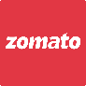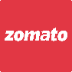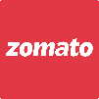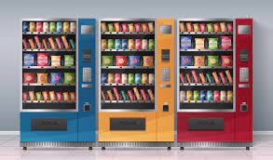 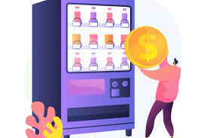 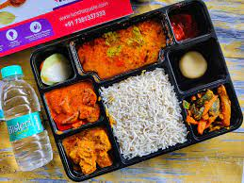

***HYPERPURE***

Hyperpure is Zomato's B2B platform that supplies fresh and packaged food products to restaurants. It can be a game-changer for Zomato in the following ways:

* **Improved customer experience:** Hyperpure can help restaurants to improve the quality and freshness of their food, which will lead to a better customer experience. This will help Zomato to attract more customers and improve its retention rates.
* **Increased efficiency:** Hyperpure can help restaurants to save time and money by streamlining their procurement process. This will make it easier for restaurants to focus on their core business, which will benefit Zomato.
* **Enhanced insights:** Hyperpure can provide Zomato with insights into the food industry that can be used to improve its products and services. This will help Zomato to stay ahead of the competition and grow its business.

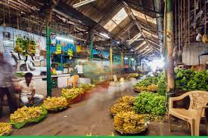 

The key focus areas for Zomato in order to make Hyperpure a success are:

* **Building a strong supply chain:** Zomato needs to build a strong supply chain to ensure that Hyperpure can provide restaurants with the freshest and highest-quality food products. This includes working with reliable suppliers and ensuring that the products are delivered on time and in good condition.
* **Providing excellent customer service:** Zomato needs to provide excellent customer service to restaurants that use Hyperpure. This includes being responsive to their queries and resolving any issues quickly and efficiently.
* **Promoting Hyperpure:** Zomato needs to promote Hyperpure to restaurants in order to generate awareness and demand for the platform. This can be done through marketing and advertising, as well as through partnerships with industry associations and other organizations.

Here are some of the key challenges faced by restaurants

* **Lack of access to fresh and high-quality food products:** Many restaurants struggle to get access to fresh and high-quality food products. This can lead to food quality issues, which can impact customer satisfaction.
* **High prices of food products:** The prices of food products can be high, which can put a strain on the profitability of restaurants.
* **Time-consuming and inefficient procurement process:** The procurement process can be time-consuming and inefficient, which can take away from the time that restaurants could be spending on other tasks.

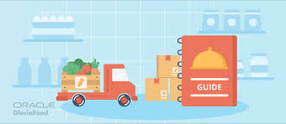

* **Lack of transparency in the supply chain:** Restaurants often lack transparency in the supply chain, which can make it difficult to track the quality and freshness of the food products they are using.

The following are some strategies that Zomato can adopt to form a sustainable business model for Hyperpure:

* 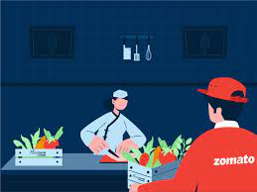**Charge a premium:** Zomato can charge a premium for Hyperpure, as the platform offers a number of benefits that are not available from other suppliers.
* **Offer discounts and promotions: Zomato** can offer discounts and promotions to restaurants that sign up for Hyperpure. This will help to attract new customers and encourage existing customers to use the platform more often.
* **Bundle Hyperpure with other Zomato products and services:** Zomato can bundle Hyperpure with other products and services, such as food delivery or table booking. This will make it more attractive to restaurants and help to increase adoption.
* **Partner with other businesses:** Zomato can partner with other businesses, such as food manufacturers or distributors. This will help to expand the reach of Hyperpure and make it more accessible to restaurants.

By focusing on these areas, Zomato can make Hyperpure a successful and sustainable business model.

Here are some different user personas and use cases for Hyperpure:

* **Restaurant owner:** A restaurant owner who is looking for a reliable and efficient way to procure fresh and high-quality food products.
* **Head chef:** A head chef who is looking for innovative and creative ways to use fresh ingredients.

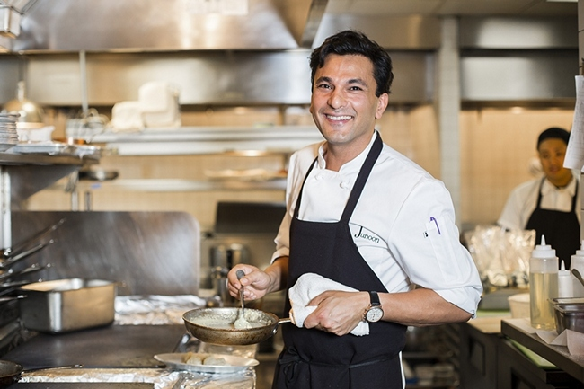

* **Sous chef:** A sous chef who is responsible for managing the day-to-day operations of the kitchen.
* **Purchasing manager:** A purchasing manager who is responsible for sourcing food products at the best possible prices.
* **Restaurant manager:** A restaurant manager who is responsible for the overall operation of the restaurant.

These are just a few examples of the many different user personas and use cases for Hyperpure. By understanding the needs of these different users, Zomato can create a platform that is valuable and useful to them.